# Different Views

Invarion Cloud lets you view your plans in three different ways:

| View | Description |
| --- | --- |
| **Table View** | The Table view presents all of your plans in a table. The table shows the document name, the date it was created, last modified and the editor’s name. You can also see if a plan is public, private and or has been shared with a collaborator. You can sort your plans by clicking on column’s heading to order by plan’s name, creation date or last modified date. |
| **Tile View** | The tile view presents your plans as a series of thumbnail images. The tiles show a preview of the plan, for easy identification. Shared plans have special overlay icon that indicates that a plan has been shared. To sort in tile view click on “sort” button on the top bar and choose a desired sorting option. |
| **Map** | The map view displays your plans on a map. This can be useful when searching for a plan at a specific location, or for visualizing clusters of projects within a particular region. Plans displayed on the map will show depending on the folder you are currently in. To see all of your plans on the map, open map view while in the “All Plans” section. |

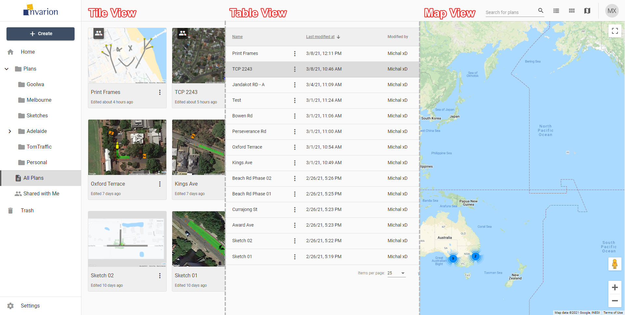

Different Views

To change the view use the appropriate buttons on the top bar.

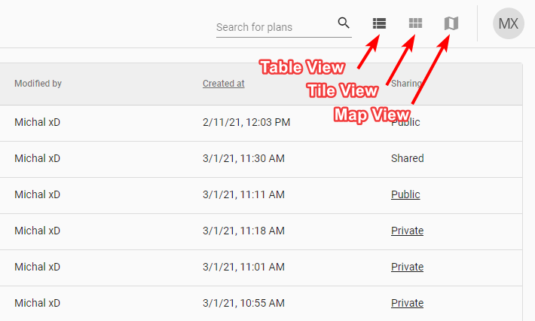

View Toggler

You can change the view at any moment. It won’t reset your current location or search results. The view you last selected will be saved in your browser as your default view. So next time you enter Invarion Cloud your preferred view will be shown.